Weight Loss Smoothie Recipes and 7 Day Diet Plan

Day 1
Breakfast
Strawberry Oatmeal Smoothie:
1 cup banana slices, 1 cup strawberries, 1 cup grapefruit juice, ¼ cup oats
Lunch
Green Smoothie:
1 cup avocado cubes, 1 cup tomato slices, 1 cup almond milk, 1 cup spinach, 1 tablespoon chia seeds, ½ inch ginger, 3 pitted dates (optional sweetener)
Dinner
Peanut Smoothie:
2 cups banana slices, 1 cup peanut milk, 2 tablespoons peanut butter, ¼ cup peanuts
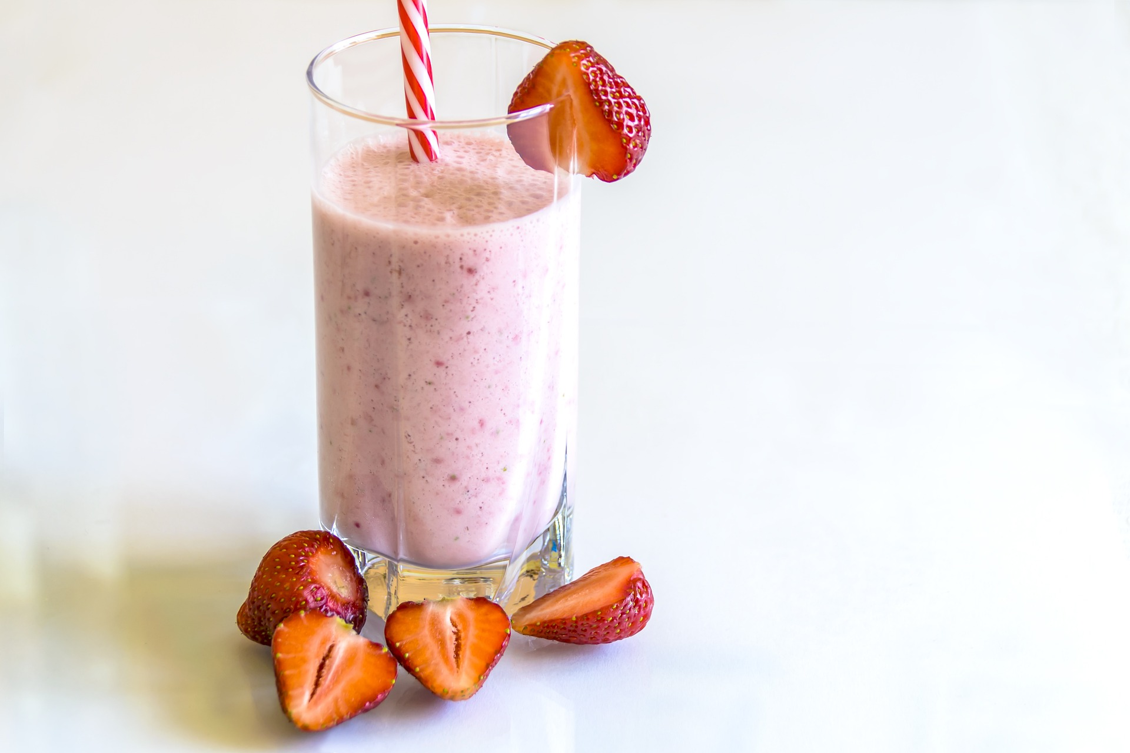

Day 2
Breakfast
Papaya Oatmeal Smoothie:
1 cup banana, 1 cup papaya cubes, 1 cup grapefruit juice, ¼ cup oats
Lunch
Broccoli Smoothie:
1 cup avocado cubes, 1 cup broccoli, 1 cup almond milk, 1 tablespoon chia seeds, ½ inch turmeric, 3 pitted dates (optional sweetener)
Dinner
Almond Smoothie:
2 cups banana slices, 1 cup almond milk, 2 tablespoons almond butter, ¼ cup almonds
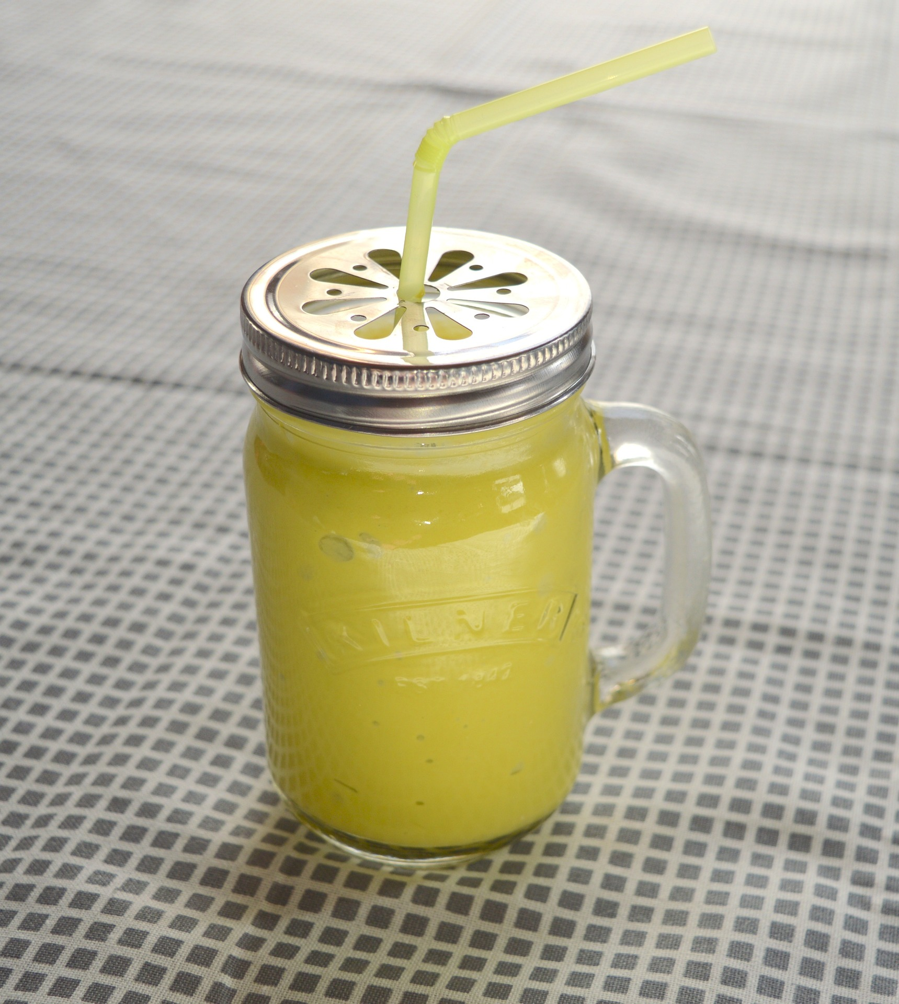

Day 3
Breakfast
Orange Oatmeal Smoothie:
1 cup banana slices, 1 cup orange slices, 1 cup grapefruit juice, ¼ cup oats
Lunch
Sweet Potato Smoothie:
1 cup banana slices, 1 cup boiled sweet potato, 1 cup almond milk, 1 tablespoon chia seeds, ½ inch ginger, ½ inch turmeric
Dinner
Cashew Smoothie:
2 cups banana slices, 1 cup cashew milk, 2 tablespoons cashew butter, ¼ cups cashew nuts
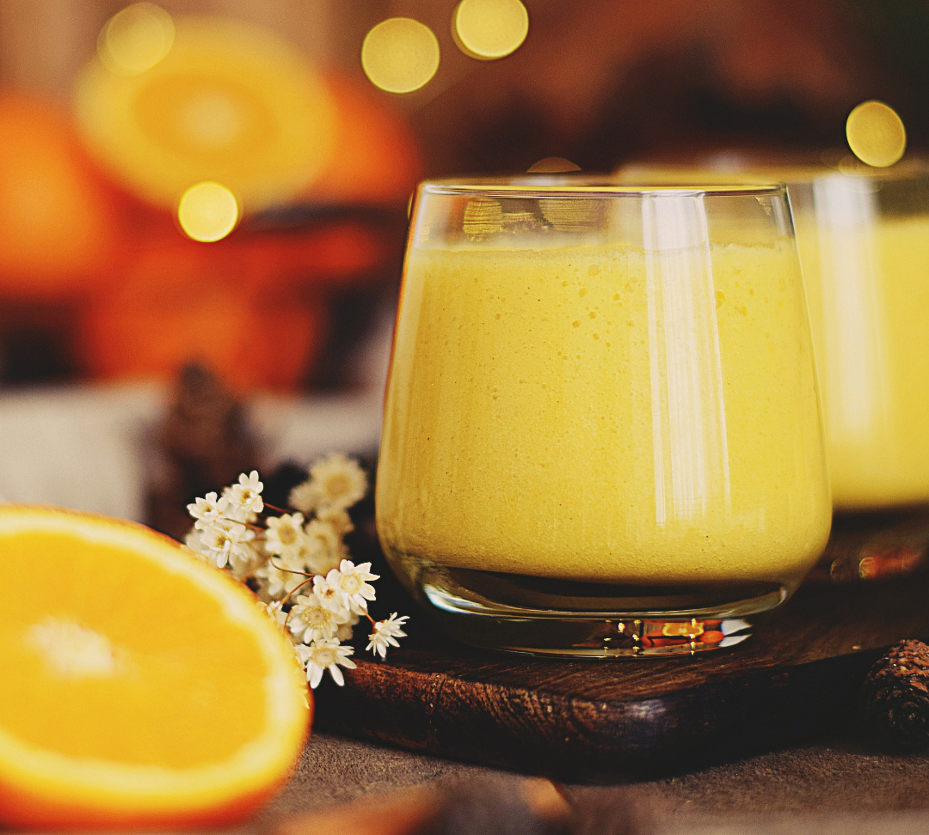

Day 4
Breakfast
Apricot Oatmeal Smoothie:
1 cup banana slices, 1 cup pitted apricots, 1 cup grapefruit juice, ¼ cup oats
Lunch
Pumpkin Pie Smoothie:
1 cup banana slices, 1 cup boiled pumpkin, 1 cup almond milk, ¼ teaspoon cinnamon, ¼ teaspoon ginger, ¼ teaspoon allspice, ¼ teaspoon cloves, 3 pitted dates (optional sweetener)
Dinner
Coconut Smoothie:
2 cups banana slices, 1 cup grated coconut flesh, 1 cup coconut water
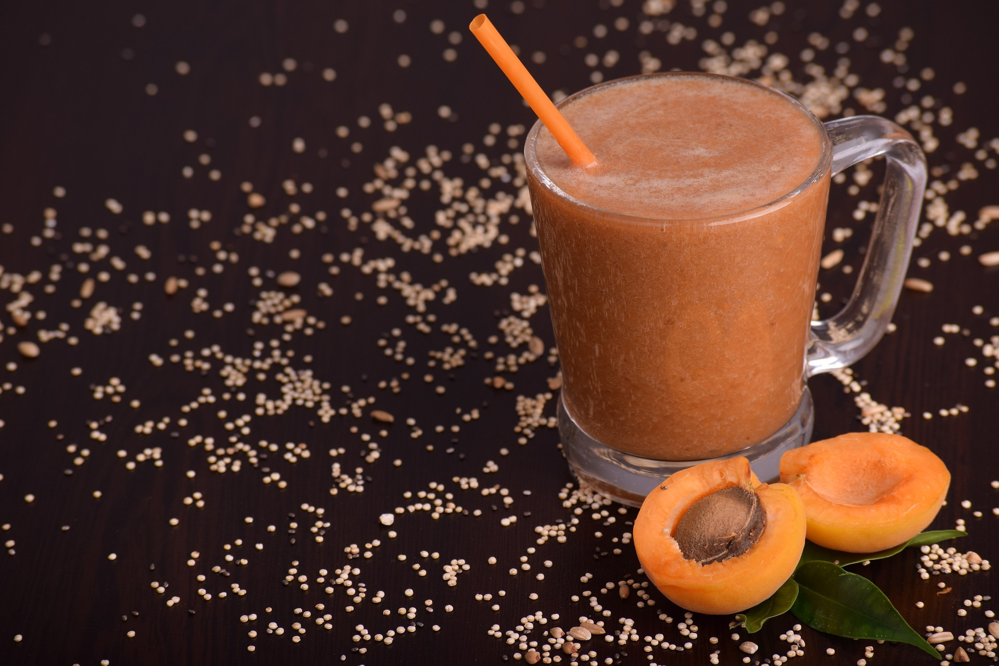

Day 5
Breakfast
Apple Oatmeal Smoothie:
1 cup banana slices, 1 cup apple slices, 1 cup grapefruit juice, ¼ cup oats
Lunch
Carrot Cake Smoothie:
1 cup banana slices, 1 cup carrots, 1 cup almond milk, ¼ teaspoon cinnamon, ¼ teaspoon ginger, ¼ teaspoon nutmeg, 3 pitted dates (optional sweetener)
Dinner
Peanut Smoothie:
2 cups banana slices, 1 cup peanut milk, 2 tablespoons peanut butter, ¼ cup peanuts
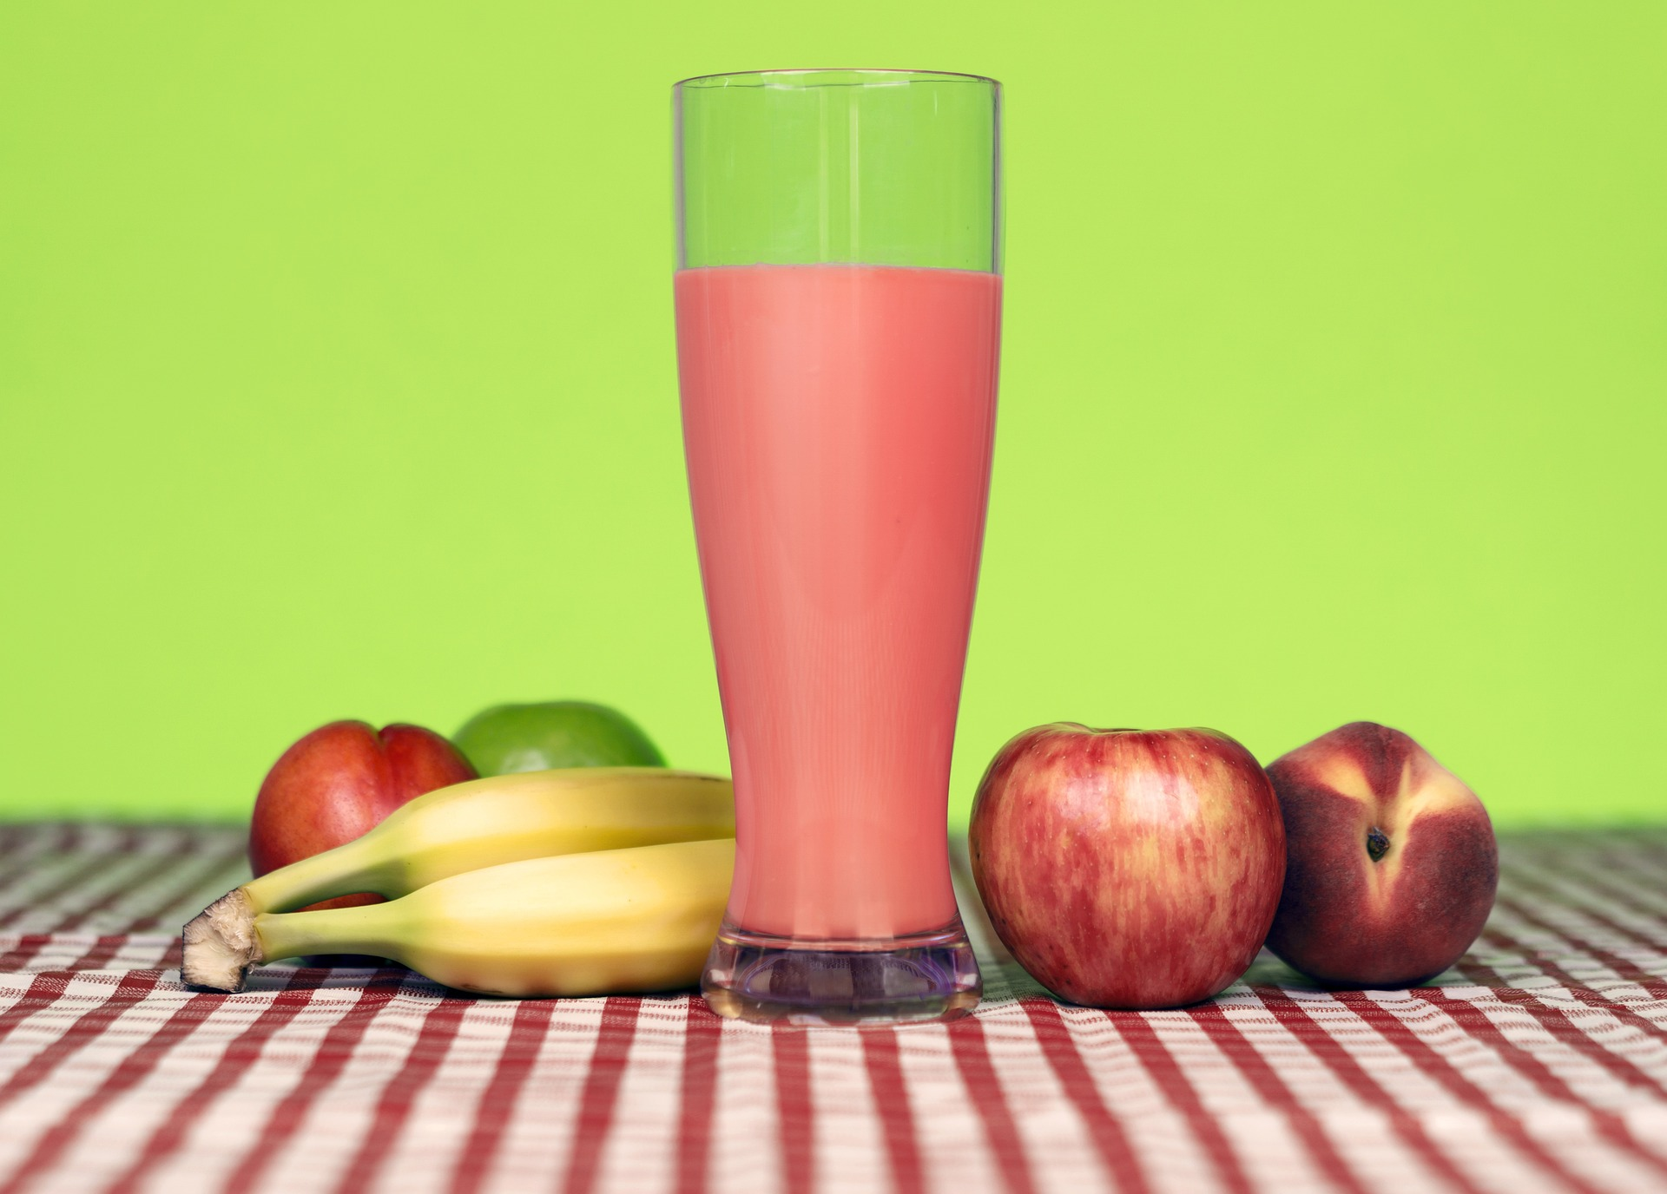

Day 6
Breakfast
Melon Oatmeal Smoothie:
1 cup banana slices, 1 cup watermelon cubes, 1 cup grapefruit juice, ¼ cup oats
Lunch
Bean Smoothie:
1 cup banana slices, 1 cup boiled beans, 1 cup almond milk, ¼ teaspoon paprika, ¼ teaspoon ginger, ¼ teaspoon turmeric, 3 pitted dates (optional sweetener)
Dinner
Almond Smoothie:
2 cups banana slices, 1 cup almond milk, 2 tablespoons almond butter, ¼ cup almonds
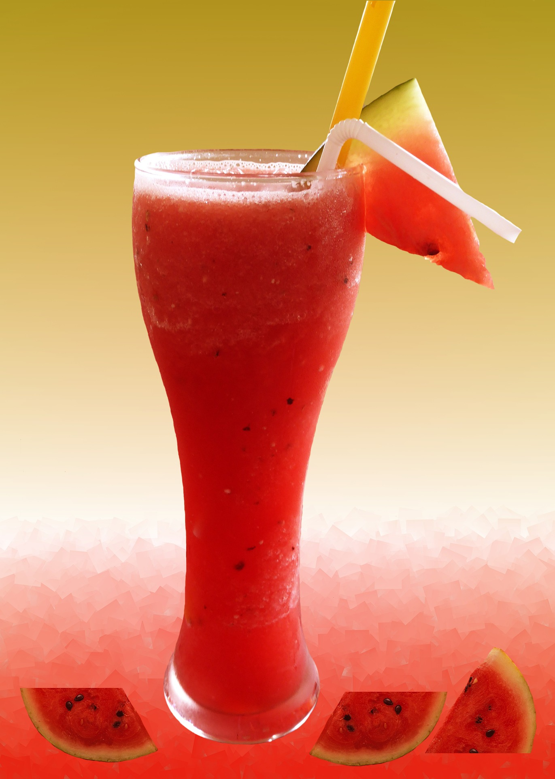

Day 7
Breakfast
Pina Colada Oatmeal Smoothie:
1 cup banana slices, 1 cup pineapple wedges, 1 cup coconut milk, ¼ cup oats
Lunch
Green Smoothie:
1 cup avocado cubes, 1 cup tomato slices, 1 cup almond milk, 1 cup spinach, 1 tablespoon chia seeds, ½ inch ginger, 3 pitted dates (optional sweetener)
Dinner
Cashew Smoothie:
2 cups banana slices, 1 cup cashew milk or another nut milk, 2 tablespoons cashew butter, ¼ cups cashew nuts
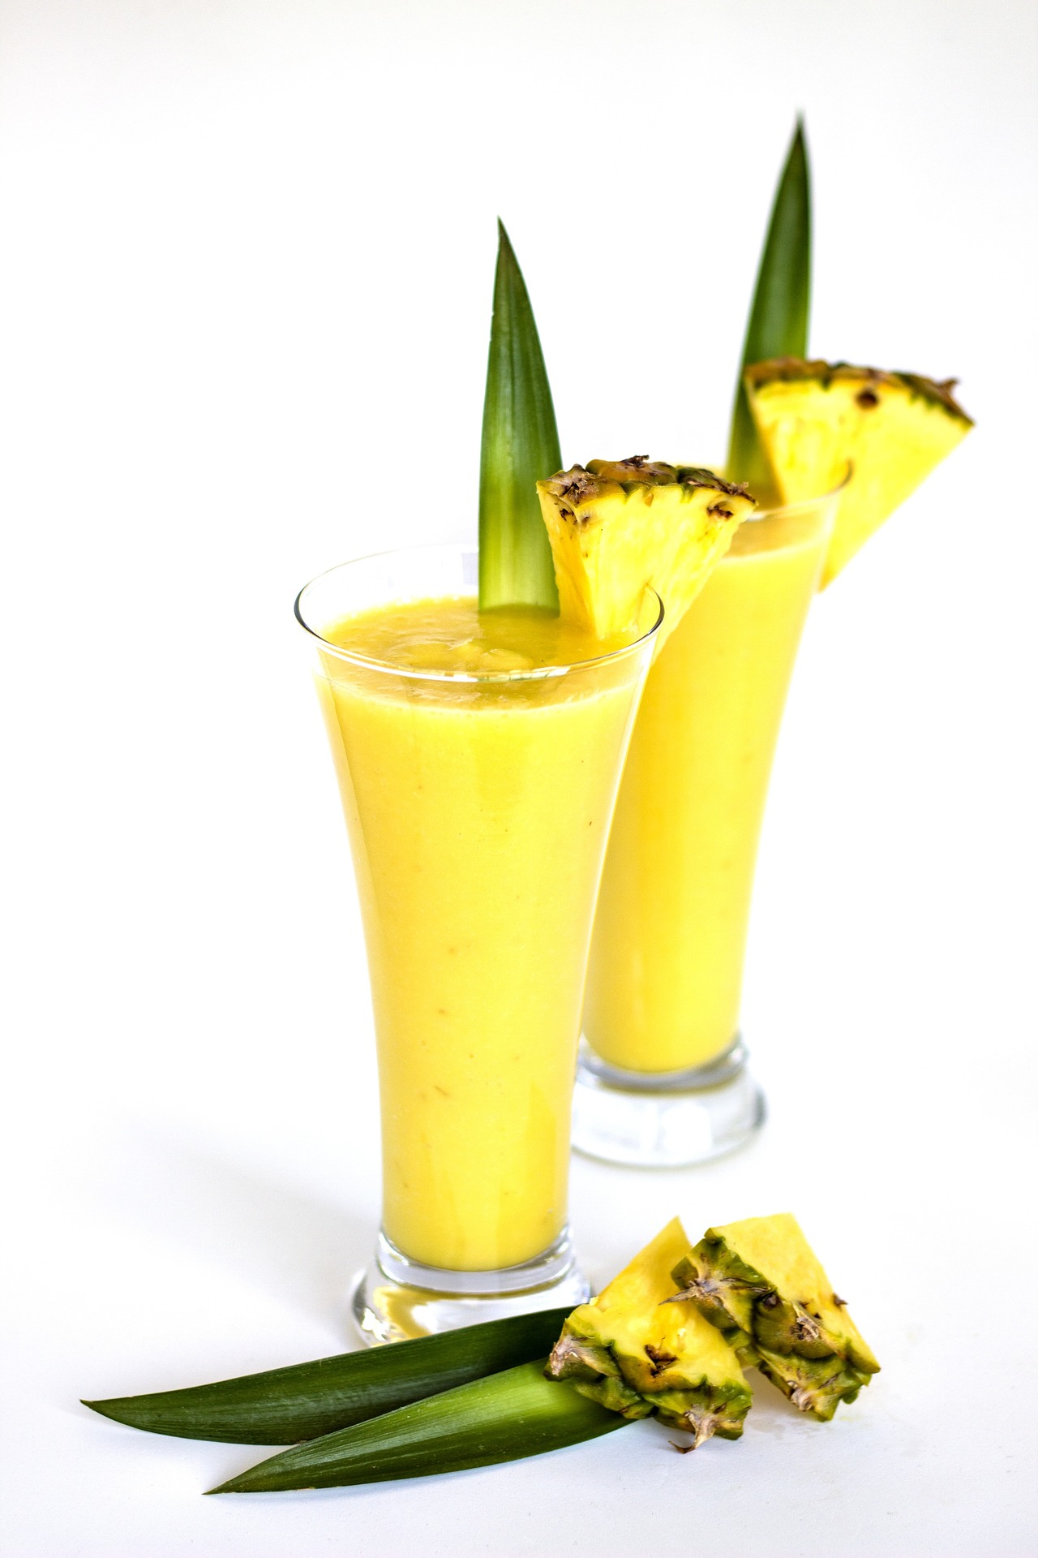
The Acne Diet Book
To learn more smoothie recipes, read The Acne Diet Book which contains:
The Acne Diet Book teaches you the foods to avoid and the foods to eat for natural acne treatment.
It also teaches you the hormonal acne diet, the anti-inflammatory diet for acne and the supplements for acne treatment.
This acne treatment book also contains an acne free diet meal plan to help you follow an anti acne diet at home.
This acne cure book also has numerous acne smoothie recipes that include:
*Hormonal acne smoothies
*Smoothies for acne scars
*Smoothies for acne spots (hyperpigmentation)
*Anti-inflammatory diet smoothies for acne
*Detox smoothies for clear skin
*Smoothies for clear skin and weight loss
Click here to buy The Acne Diet Book
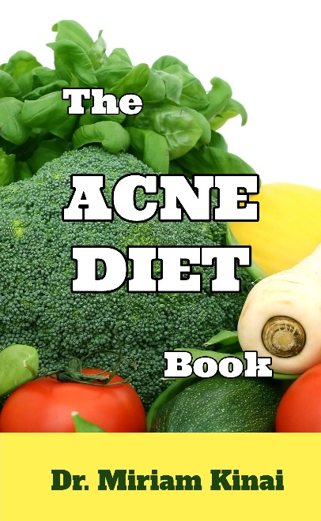
Click here to buy The Acne Diet Book

